Xilinx Hardware

The hardware used is the Xilinx Kria KV260 Vision AI Starter Kit as shown in Figure 1.

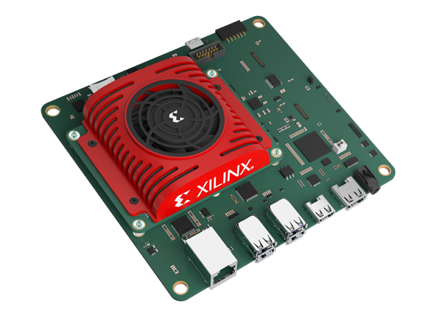Figure 1: Kria KV260 Board
Based on the Zynq UltraScale MPSoC architecture, and paired with 4 GB of DDR4 memory the board is suitable for a range of AI accelerated applications. The kit is an out-of-the-box ready development environment for applications such as smart cameras, AI face detection and defect detection with machine vision.
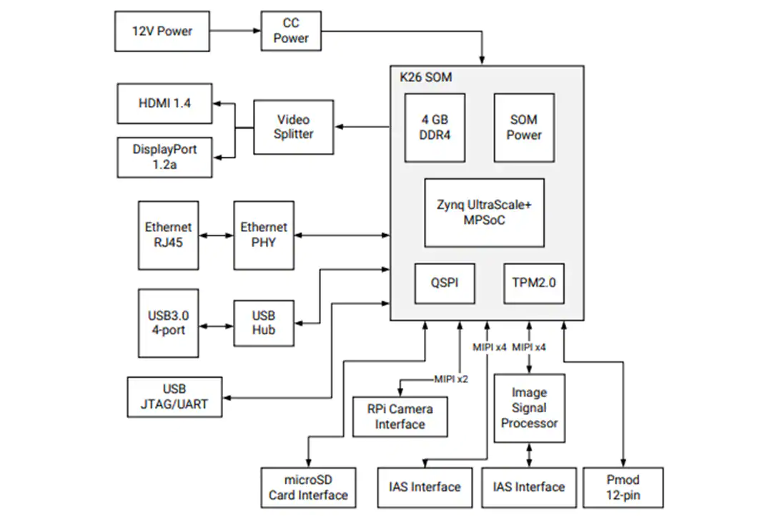Figure 2: KV260 Block Diagram
The kit has a MIPI CSI-2 interface which allows for easy connectivity and direct integration of the Raspberry Pi camera module and runs the Petalinux operating system. This OS is a version of Linux which has been customized for Xilinx FPGA devices.

The Vitis Video Analytics SDK (VVAS) can be used alongside Petalinux to create powerful AI applications.

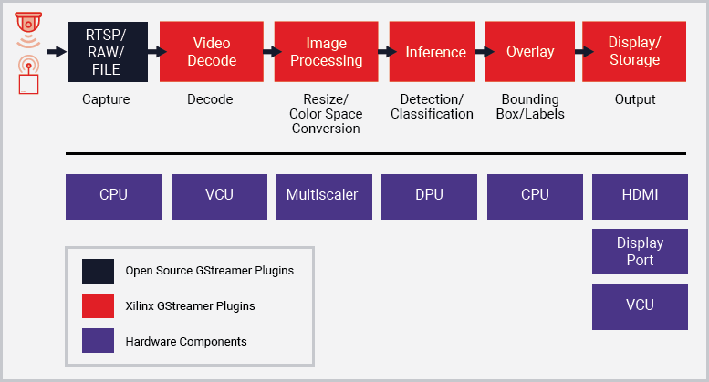Figure 3: Xilinx VVAS

